**Project Design Phase-II**

**Data Flow Diagram & User Stories**

|  |  |
| --- | --- |
| Date |  |
| Team ID | LTVIP2025TMID59098 |
| Project Name | Revolutionizing Liver Care |
| Maximum Marks | 4 Marks |

**Data Flow Diagrams:**

A Data Flow Diagram (DFD) is a traditional visual representation of the information flows within a system. A neat and clear DFD can depict the right amount of the system requirement graphically. It shows how data enters and leaves the system, what changes the information, and where data is stored.

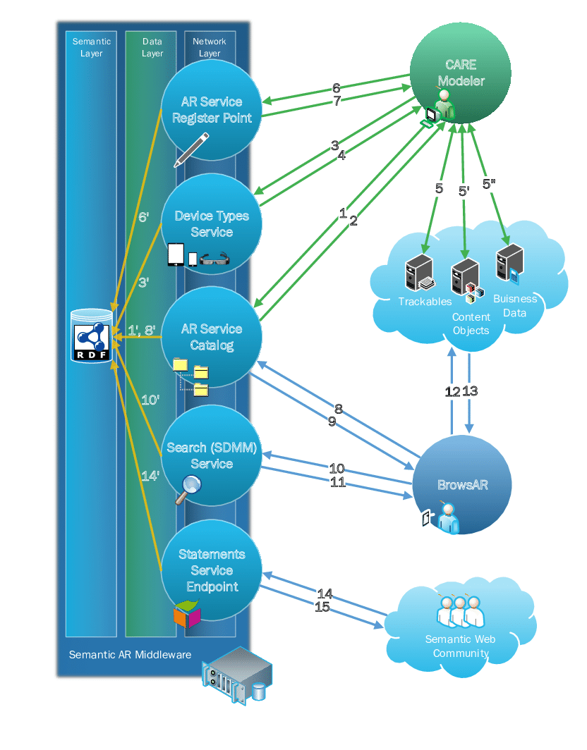

**Example :**

Step 1: Data Collection & Digitization

Step 2: Preprocessing & Feature Extraction

Step 3: Model Training & Explainability

Step 4: Validation & Regulatory Approval

Step 5: Deployment in Clinical Trials & Practice

Step 6: Monitoring, Feedback & Optimization

